Here is a design specification for an agentic application which queries four language models with the same query.
Language Models
- To start: Gpt 5.1, Sonnet 4.5, Gemini 3, Grok 4.1.
- For now, I can access gpt and grok through my azure account.
- We can access Sonnet and Gemini through subscriptions that I have with them.
- Each Model Agent encapsulates its LLM API call as an internal tool, maintaining separation between agent orchestration logic and model invocation.
User Interface (see wireframe below)
- At the top, render 4 cells across two rows, each with two columns, with each cell containing the results from one of the models.
- Each cell should contain a read-only, scrollable text-area.
- Each cell should have a copy to clipboard in markdown format button.
- In the middle, render another read-only, scrollable text area that stretches across the page horizontally.
- Add a copy to clipboard in markdown format button.
- At bottom, render a prompt text-area HTML element that stretches across the screen.
- Include a Search Button and Clear Button.
Prompt Clarification Step
- When the search button is invoked, the supervisor agent will receive and record the initial prompt:
Supervisor receives: { user_prompt: "Explain quantum computing", mode: "search

Searching
- The supervisor will then fan-out the query to each model child agent for parallel inferencing passing state as a structured JSON object:
{ refined_prompt: "...", conversation_id: "abc-123", role: "responder" // vs "debater" later }
- Each model child agent will load its prompt template
- Call its model
- Maintain chat history for each turn, reasoning logic, and other state in its own local state store:
GPT Agent state: { agent_id: "gpt", conversation_history: [ { role: "user", content: "refined prompt..." }, { role: "assistant", content: "my response..." } ]}
- The model child agent will also stream its response back to the Supervisor as a structured JSON object.
- The Supervisor will collect child agent state in a structured JSON object:
Supervisor state: { conversation_id: "abc-123", original_prompt: "...", refined_prompt: "...", responses: { gpt: { text: "...", status: "complete" }, claude: { text: "...", status: "complete" }, gemini: { status: "pending" }, grok: { status: "pending" } }
- Upon completion, the orchestrator agent will the completion to the corresponding UI widget.
- Upon completion of all child agents, the orchestrator agent will send all child agent responses to the Summary tool, which synthetize and summarize responses and output to the summary UX.
- The local state store for each agent will be abstracted in an interface allowing for different state stores to plug-in dynamically.
- To be clear, two copies of each model child agent response will be maintained:
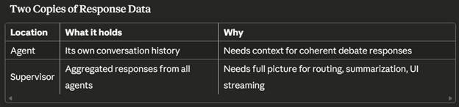

Rules of the Road
- All agent/tool communication is encapsulated in structured JSON. No native strings.
- Nothing is hard-coded. Use interface and a provider model for everything.
- When the copy button is invoked, the targeted agent will return state in to the user’s clipboard in MarkDown format.
- Please wrap all code with structured exception handling.
- Please capture telemetry using Azure Application Insights.
- Please implement authentication against Azure Entra implementing the Azure Default Credential constructs.
- Each agent will include a prompt template with placeholders to inject the prompt snippets passing by the Supervisor agent.
